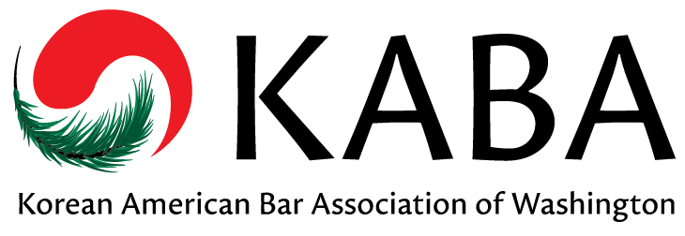 | Korean American Bar Association of Washington  Membership Form

MEMBERSHIP: New Member Renewing Member  Attorney  Law Student  Other Legal Professional:  CONTACT INFORMATION:  (As it should appear in the KABA Directory)  Name:  Title (if applicable):  Practice Area(s):  Firm/Company:  Address:  Phone:  Fax:  E-mail:  I do NOT want to receive announcements by email.  OTHER:  Law School:  Year Grad (or expct’d):  Languages Spoken:  Please do NOT list me in the KABA Membership Directory |  | KABA INTERESTS: (check all that apply)  Annual Banquet  Judicial Evaluations (min 3 yrs practice req)  Membership / Networking / Social Activities  Mentorship Program  Pro Bono Service  Professional Development / CLE  Website / Newsletter  Other Interests:  MEMBERSHIP DUES:  $50 Private Attorneys  $35 Public Sector Attorneys*  FREE Law Students  FREE Hardship Exemption**  Annual membership dues help to fund all KABA programs including student scholarships, the Korean pro-bono legal clinics, membership events, and community outreach efforts.  * Public sector attorneys include government attorneys, judges, prosecutors, public defenders, assistant attorneys general, legal services attorneys and attorneys for non-profit groups which qualify as 501(c)(3) organizations.  **KABA is offering a hardship exemption for attorneys who are currently unemployed.  DONATIONS:  Yes! I would like to support KABA and its programs!  $100  $50  $25  $____
Please make checks payable to Korean American Bar Association of Washington and mail payment and membership form to:
Helsell Fetterman LLP
c/o Michelle Su
1001 4th Ave, Ste 4200
Seattle, WA 98154

Payment may also be made via Venmo @KABA-Washington and completed forms may be emailed to kabawaboard@gmail.com.
www.kaba-washington.org

The Korean American Bar Association of Washington is proud to be an affiliate of the National Asian Pacific American Bar Association (NAPABA).

